DAY25_Strings & Tuples
Challenge 1: Student Name Formatting
A student database stores names in inconsistent formats.
Task
Convert all names to proper case (First letter capital).
Input
students = ("sunitha", "RAVI", "aNu")
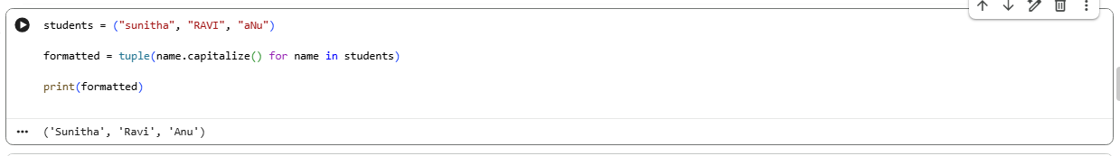
Challenge 2: Count Total Subjects
Each student has subjects stored in a tuple.
Input
subjects = ("Math", "Science", "English", "Math", "Science") Task Find:
Total subjects
Unique subjects
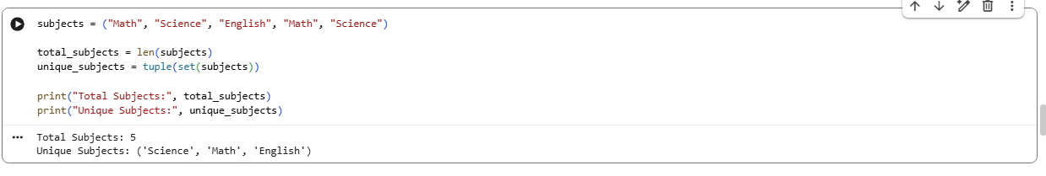

Challenge 3: Remove Extra Spaces from Feedback
Student feedback contains unwanted spaces.
Input
feedback = (" good course ", " excellent ", "average ")
Task
Clean all feedback strings 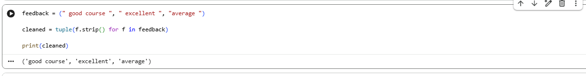
Challenge 4: Combine Student Name & Course
You have separate tuples for names and courses.
Input
names = ("Anu", "Ravi", "John") courses = ("Python", "SQL", "Power BI")
Task
Create a tuple:
('Anu-Python', 'Ravi-SQL', 'John-Power BI')
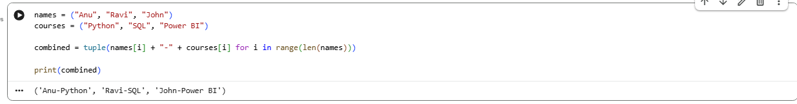
Challenge 5: Extract Email Domains
Student emails are stored in tuple.
Input emails = ("anu@gmail.com", "ravi@yahoo.com", "john@edu.com") Task
Extract domains
